# Using the AI Essay Reviewer Tool

Add the ‘OPENAI_API_KEY’ in system environment variables

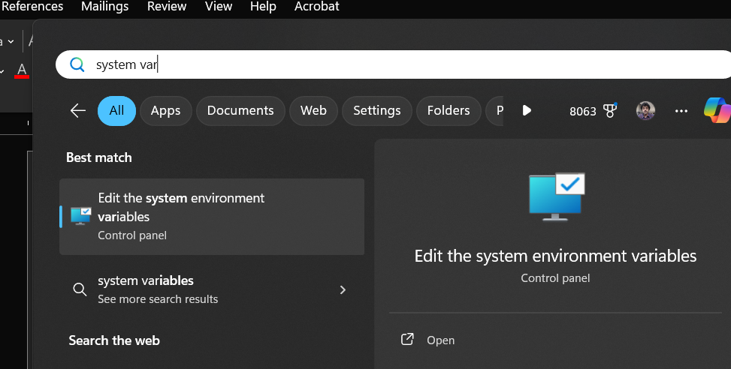

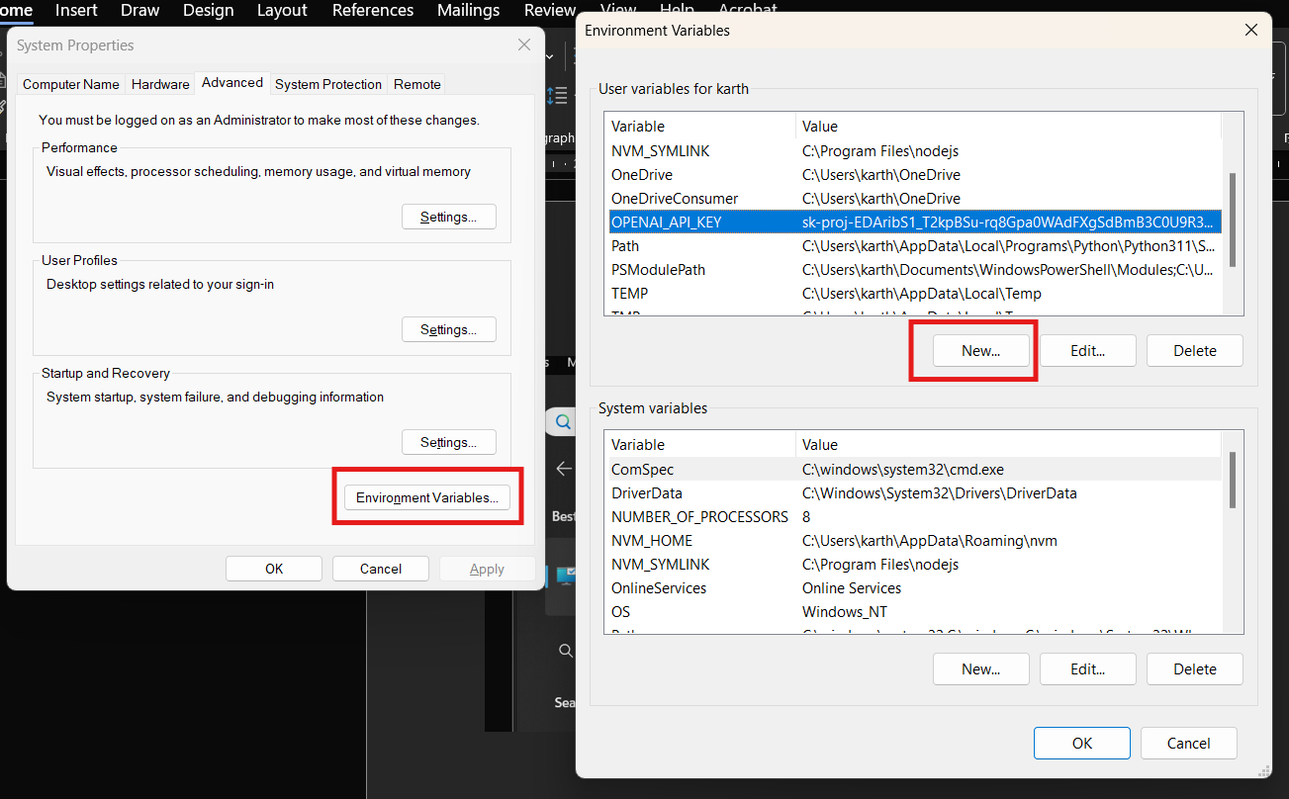

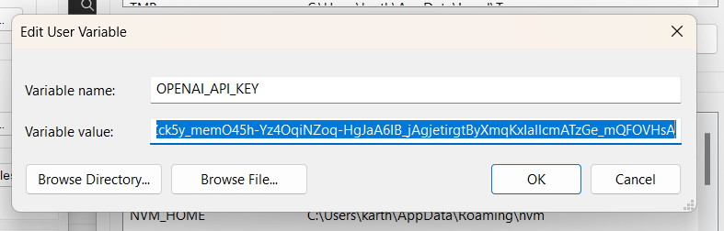

Prompt engineering

This guide shares strategies and tactics for getting better results from large language models (sometimes referred to as GPT models) like GPT-4o. The methods described here can sometimes be deployed in combination for greater effect. We encourage experimentation to find the methods that work best for you. [Prompt engineering - OpenAI API](https://platform.openai.com/docs/guides/prompt-engineering)

Sample prompt json file

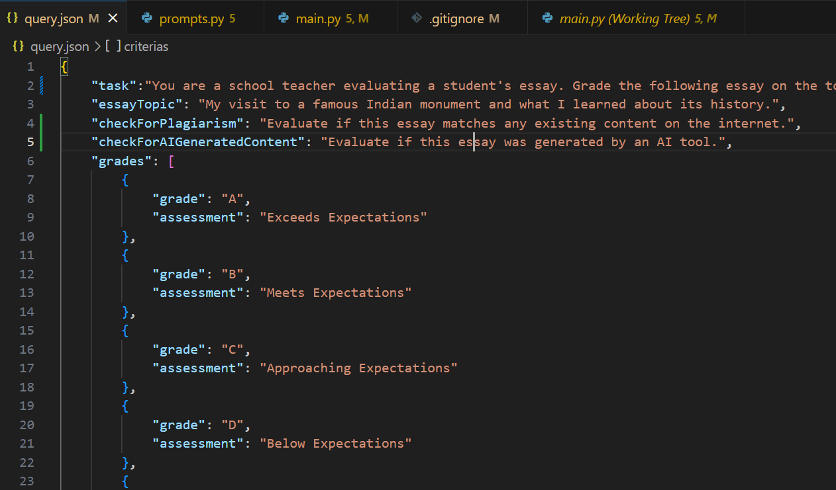

Starting the tool from Windows command prompt

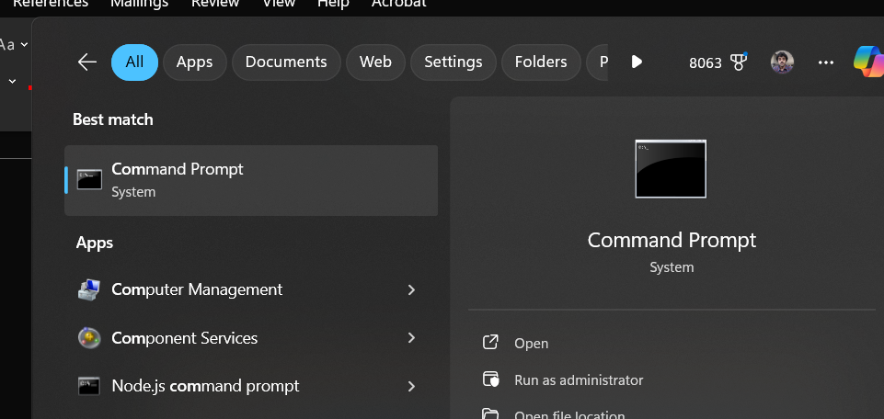

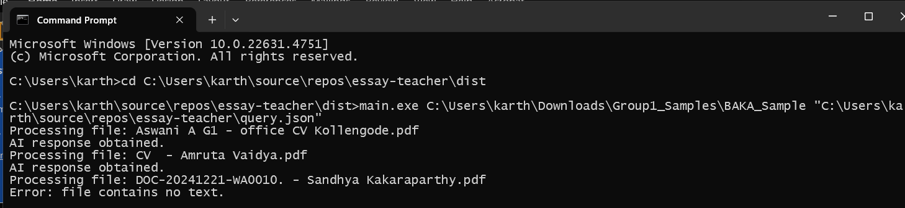

**Command**: “Path to the ‘AIEssayReviewer.exe’” “Path to the folder containing the essays in pdf format” “Path to the json file containing the prompts to ChatGPT”

Example: AIEssayReviewer.exe “C:\Users\karth\Downloads\Group1_Samples\BAKA_Sample” "C:\Users\karth\source\repos\essay-teacher\query.json"

Results from the AIEssayReviewer contains

* AIEssayReview_.csv: contains results from all the files, including AI review
* Log file: logs which contains the entire response from the AI model, useful as a reference

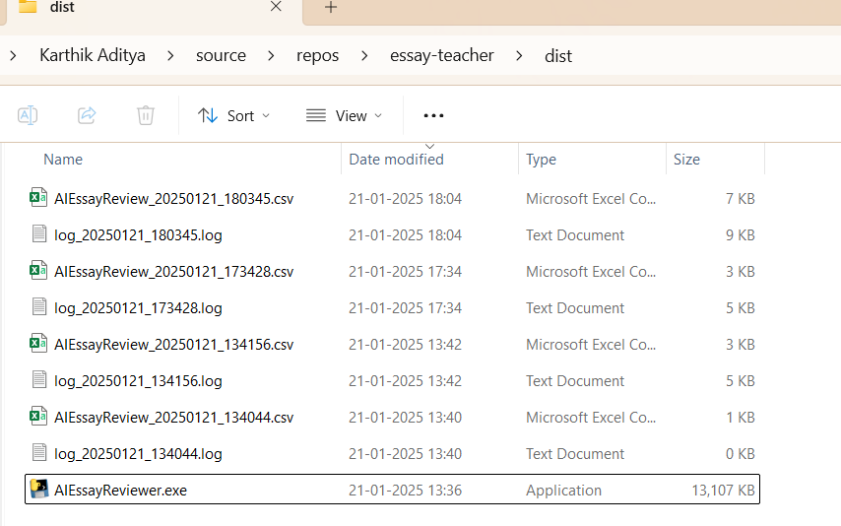

Sample response in the .csv file

